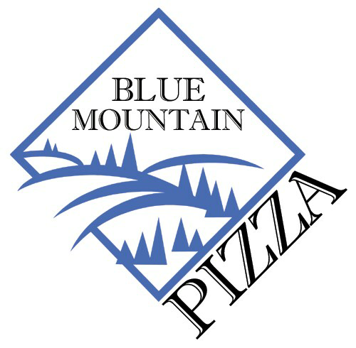
Our 17th Annual Free Community Thanksgiving Dinner
November 24, 2022

The answer is yes, BMP will be holding our Thanksgiving dinner this year and like last year, it will be different. This year with our dining room back open we will have inside seating as well as a pick up option. So, if you are alone or in need you will be able to enjoy a traditional dinner of turkey, ham, potatoes, vegetables and dessert. If you will be dining with us at Blue Mountain all you need to do is join us between noon and 3 PM. No reservations are required.
If you would like to pick up more than one meal and take it to your home to enjoy, like last year, you will need to get in touch with us ahead of time and give us some basic information.
Here are some important things to know:
The easiest and best way to get signed up is to send an e-mail between now and Monday, November 14th to: owner@bluemountainpizza.com Please include the following information; your name, address, telephone number and if you will be picking up your dinner or require it delivered. Deliveries are limited and only available in the town of Weaverville. Pick up dinners are extremely limited and only available for you and immediate family. Dinners will be available to be picked up on Thanksgiving between the hours of noon and 2pm.
If sending an e-mail is not possible then on Monday November 14th between the hours of 11am and 2pm we will have an opportunity for you to CALL-IN to BMP for a meal reservation. Phone number to call is 828-658-8778 during the above hours ONLY!
Please keep in mind that the only way one person can pick up multiple meals, like for a family, is to make arrangements prior to Thanksgiving Day via the 11/14 call-in date or emailing the above address!
We will NOT be able to customize group pick up dinners. Everyone will receive the same meal. However, you will be able to choose your dessert!!
Our goal is the same, to thank the Weaverville community for your support during the year and to guarantee everyone has a nice holiday.

